[NEW LOGO] MARLOTH PARK HONORARY RANGERS
MAKE SAFE PLANT PROTECTORS
To grow trees or bushes in Marloth you need to protect them from our browsers, often for years. It is therefore important that plant protectors pose least risk to our animals. It has happened that a giraffe had to be darted to enable a protector to be removed from its head!
Also, bear in mind the length of time they will be part of the landscape. The more natural they look, the better. E.g. Wood is more acceptable than white poles. (And, of course, they should only be protecting locally indigenous plants.)
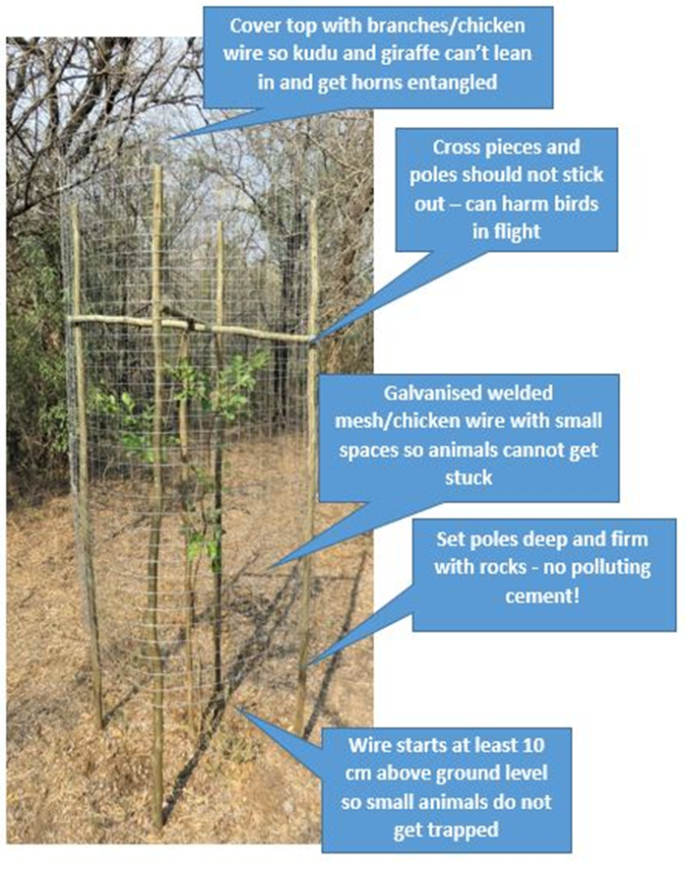
MPHR: Volunteers working to preserve the flora and fauna of Marloth Park.
Contact: 0606757275

